**AI ASSISTED CODING LAB**

ASSIGNMENT 1.2

ENROLLMENT NO :2503A51L35

BATCH NO: 20

NAME: MOHAMMED MUTAKABIR HUSSAIN

TASK1

Description: Write a comment: # Function to check if a string is a valid palindrome (ignoring spaces and case) and allow Copilot to complete it

Prompt:

Generate a comment: # Function to check if a string is a valid palindrome (ignoring spaces and case) and complete it.

Code:

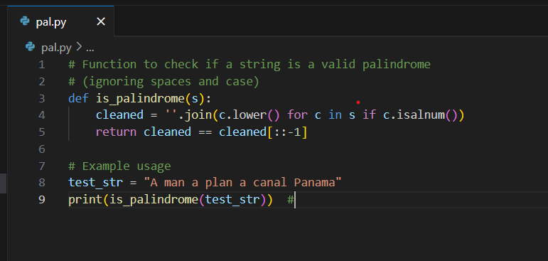

output:

**Task 2:**

DESCRIPTION:

Generate a Python function that returns the Fibonacci sequence up to n terms. Prompt with only a function header and docstring

**Prompt**:

Generate a Python function that returns the Fibonacci sequence up to n terms. The function should include only the function header and a detailed docstring and should implement with example

Code:

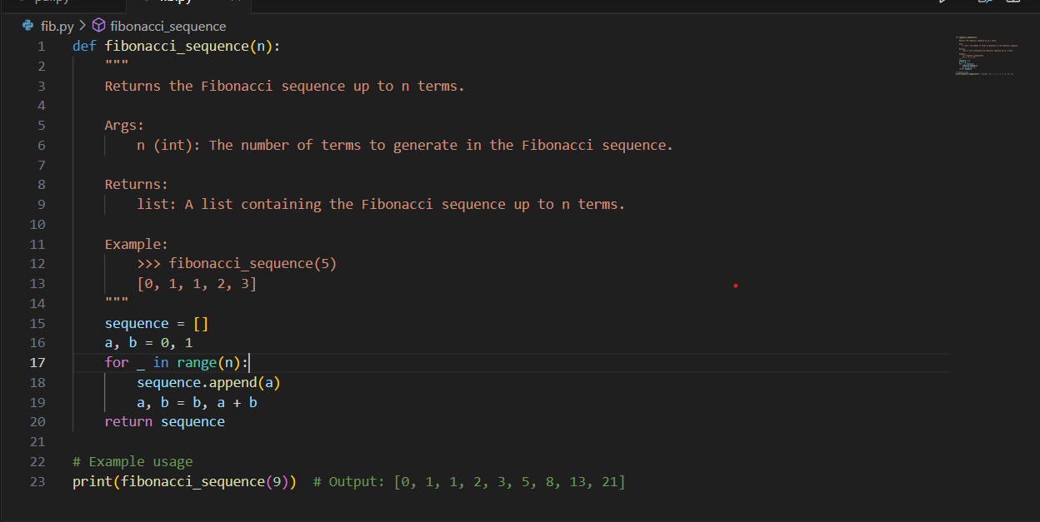

Output:

**Task 3:**

Description:

Write a comment like # Function to reverse a string and use Copilot to generate the function.

Prompt:

Write a comment like # Function to reverse a string and generate the function

Code:

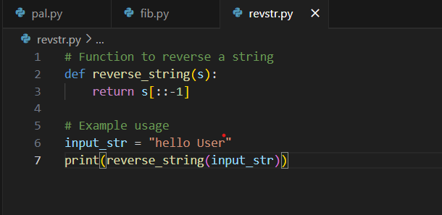

Output:

**Task 4:**

Description:

Generate a program that simulates a basic calculator (add, subtract, multiply, divide). Write the comment: # Simple calculator with 4 operations and let AI complete it

Prompt:

Simple calculator with 4 operations and let AI complete it. The program should be a fully working calculator with input/output and operator selection logic, supporting add, subtract, multiply, and divide operations

Code:

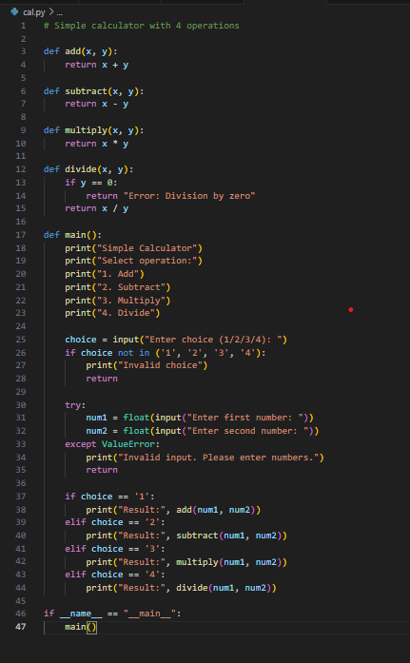

Output:

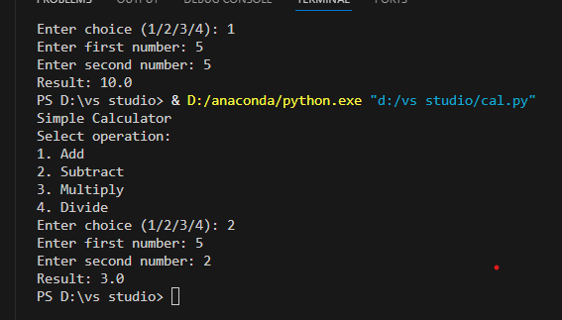

**Task 5:**

**Description:**

Use a comment to instruct AI to write a function that reads a file and returns the number of lines.

Prompt:

Write a comment instructing AI to write a function that reads a file and returns the number of lines

Code:

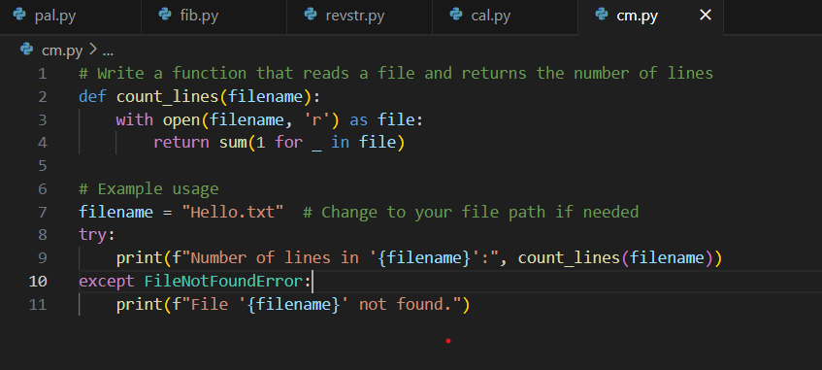

Output:

**Observations:**

While exploring GitHub Copilot, I noticed how it can generate complete and working Python programs from very minimal prompts such as comments, function definitions, or even docstrings. Across different tasks, I found that AI-assisted coding can save time, reduce effort, and increase productivity.

* **Task 1:** With just a short comment describing the requirement (checking whether a string is a palindrome), Copilot generated a correct solution that even handled cases and spaces properly.
* **Task 2:** When I provided only a function header along with a docstring for generating the Fibonacci sequence, Copilot was able to interpret the description and write the full logic.
* **Task 3:** A simple comment about reversing a string resulted in Copilot creating a neat and accurate function, showing how effectively it deals with basic operations.
* **Task 4:** By describing a “simple calculator with four operations” in a comment, I got a fully functional program with input handling and operator selection, proving its ability to generate small interactive applications.
* **Task 5:** From just one comment, Copilot generated file-handling logic to count the number of lines in a file, which shows how useful it can be in automating repetitive coding tasks.